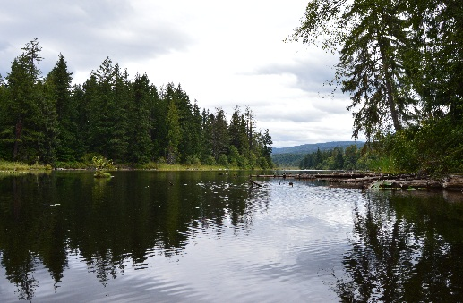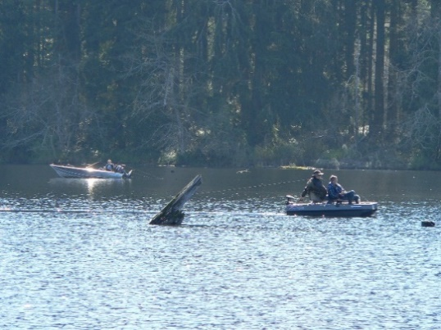

**Orca Recovery Day**

**Lake Kapowsin Aquatic Reserve**

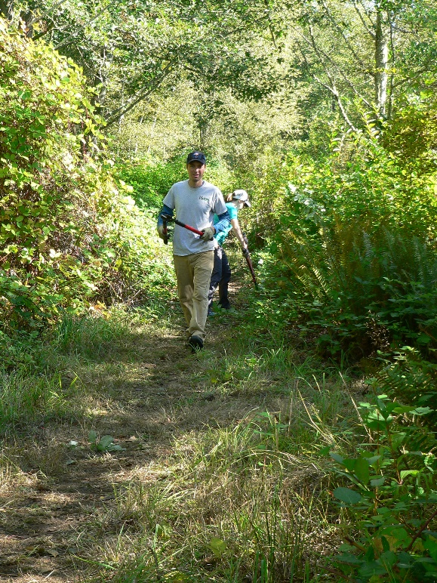

**Where is the event?** 29405 Orville Rd E, Kapowsin, WA 98344

WDFW WATER ACCESS SITE parking lot.

From the junction of Kapowsin Highway and Orville Road E (Kapowsin Grocery) the site is located less than 1 mile east on Orville Road E, parking lot is on the right.

**Please**: Dress for the weather; bring gloves, boots, tools (rake, pitchfork, clipper, lopper) & your own water

**Registration and Questions:**

Roberta.davenport@dnr.wa.gov

360-915-4005

**Covid-19 safety**

* Please bring a mask and wear it when within 6’ of others
* Maintain at least 6’ social distance from anyone outside your household
* Use hand sanitizer (will be provided)
* Pre-register with organizer

Friends of Lake Kapowsin and the Reserves Program are hosting a local Orca Recovery Day Event to increase shading and tree cover to benefit salmonid species, amphibians, nesting and perching birds along the shoreline-fishing trail through invasive species removal and planting. **Please join us!**

**Saturday, October 17, 2020**

**2 shifts 10:00 am -12:00 pm, 12:30 – 2:30**

**Pre-Registration required**